**TO DO QUERIES ON BANK DATABASE**

create table Borrower(Customer_name varchar(20),

loan_number int,

primary key (Customer_name, loan_number),

foreign key (Customer_name) references BankCustomer(Customer_name),

foreign key (loan_number) references Loan(loan_number));

insert into Borrower values('Avinash', 1);

insert into Borrower values('Dinesh', 2);

insert into Borrower values('Mohan', 3);

insert into Borrower values('Nikil', 4);

insert into Borrower values('Ravi', 5);

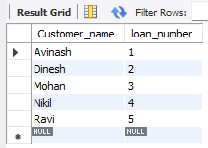

1.. SELECT d.Customer_name

FROM Depositer d

JOIN BankAccount ba ON d.Acc_no = ba.Acc_no

JOIN Branch b ON ba.Branch_name = b.Branch_name

WHERE b.Branch_city = 'Delhi'

GROUP BY d.Customer_name

HAVING COUNT(DISTINCT b.Branch_name) = (

SELECT COUNT(*)

FROM Branch

WHERE Branch_city = 'Delhi'

);



2.. select distinct b.Customer_name

from Borrower b

where b.Customer_name not in(

select d.Customer_name

from Depositer d);



3.. select distinct d.Customer_name

from Depositer d, BankAccount ba, Loan l, Borrower b

where d.Acc_no=ba.Acc_no

and ba.Branch_name='Bangalore'

and ba.Branch_name=l.Branch_name

and l.loan_number=b.loan_number

and b.Customer_name=d.Customer_name;



4.. select Branch_name

from Branch

where Assets_in_lakhs> all (

select Assets_in_lakhs

from Branch

where Branch_city='Bangalore');



5.. delete from BankAccount

where Branch_name in (

select Branch_name

from Branch

where Branch_city='Bombay');

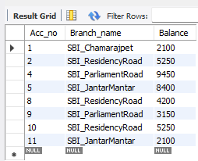

6.. update BankAccount

set Balance=Balance*1.05;

select *from BankAccount;



